DCIT 204/308: Joint DSA Semester Project
16th August 2026

Image proof:

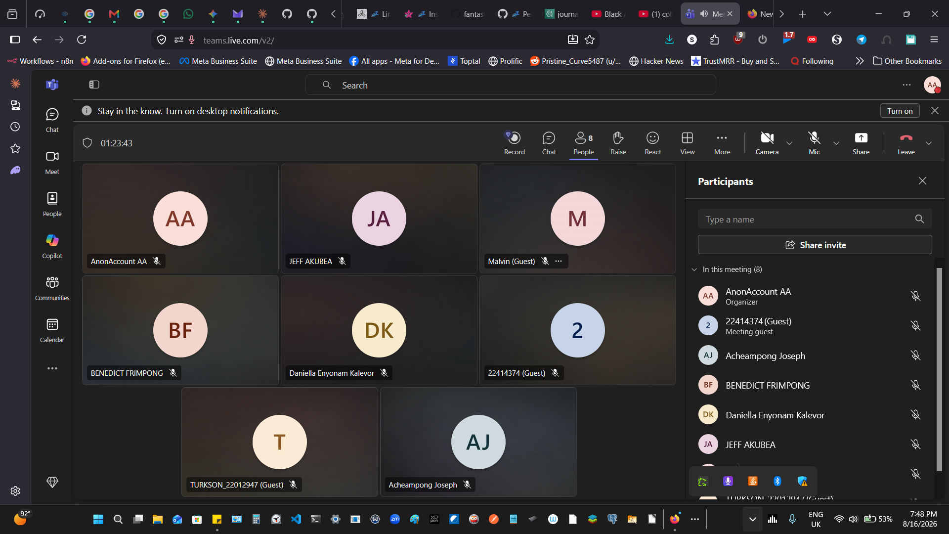
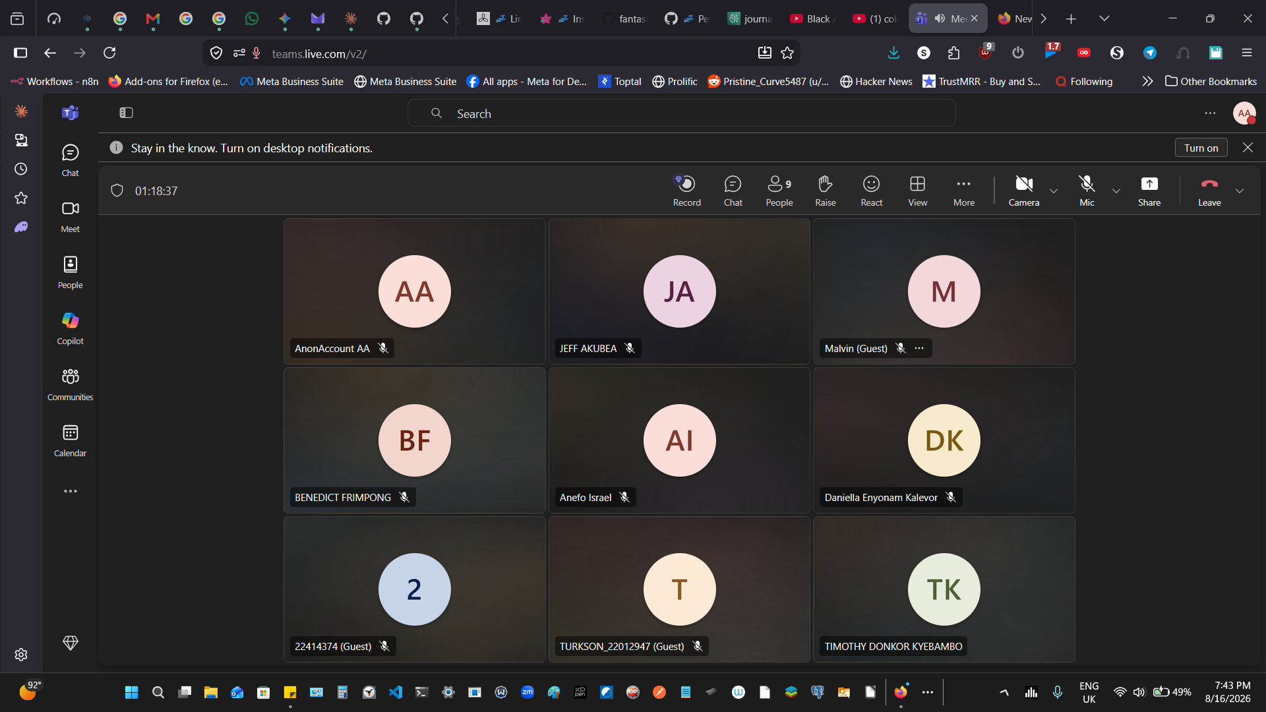
Attendees:

Meeting Attendance (the rest where unavaliable but made known of their absence so I hope they will not be penalized):
Nana Adwoa Aforo Osei - 22028283 (Group Leader / PM) (Signed in as AnonAccount)
Benedict Frimpong - 22390234
Anefo Israel - 22299195
Timothy Donkor Kyebambo - 22370734
Daniella Enyonam Kalevor - 22405426
Jeff Akubea - 22411677
David Edu Turkson - 22012947 (Signed in as TURKSON_22012947)
Sarpong Malvin Sarfo - 22300217 (Signed in as Malvin)
Hellena Osei Tuah Addo - 22414374 (Signed in as Guest 22414371)

Our Github Repo: https://github.com/NanaAdwoaDevTech/UG--DSA--Smart-Campus-Academic-Operations---IA-Dispatcher/tree/main

